CSCI 3002 – HCI

Prof. Ellen Do

Author: Erika Bailon

**Observation Paper Conducted at CSEL**

For this assignment I decided to observe how people behave and interact with technology when they are at CSEL. I took notes of how each person interacts with their own technology device and at the same time, with the people around them. The purpose of this assignment is to understand how individuals use technology in this location and how they overcome challenges or problems they run into while they’re using these devices. This allowed me to find patterns of how students carry these devices, how they use them, how they multitask while using their devices, and how they share these devices with others.

The location is CSEL. Is a common space in the Engineering Department of Computer Science wing, in the Engineering Center building. This is a medium size room that has one large desk, one round table, about 4 individual desks, 2 couches and 1 loveseat couch, and multiple chairs. They have extension for people to connect their laptops and they have two boards, so people can bring their markers and do homework there, or CA’s use it to explain. CSEL place is packed with student pretty much all day, and every day. It does not matter the time, there will always be people doing homework and studying. I have been there Saturday and Sundays and CSEL place is still full of students. I decided to go sit for an hour to do the observation on a Monday at 1:00pm. However, I have been in CSEL several times and always observe people in the place. As I said, the majority of students who spend time there, are doing homework or studying in their laptops, therefore, the type of devices I analyzed for how users interact with them, are *laptops*.

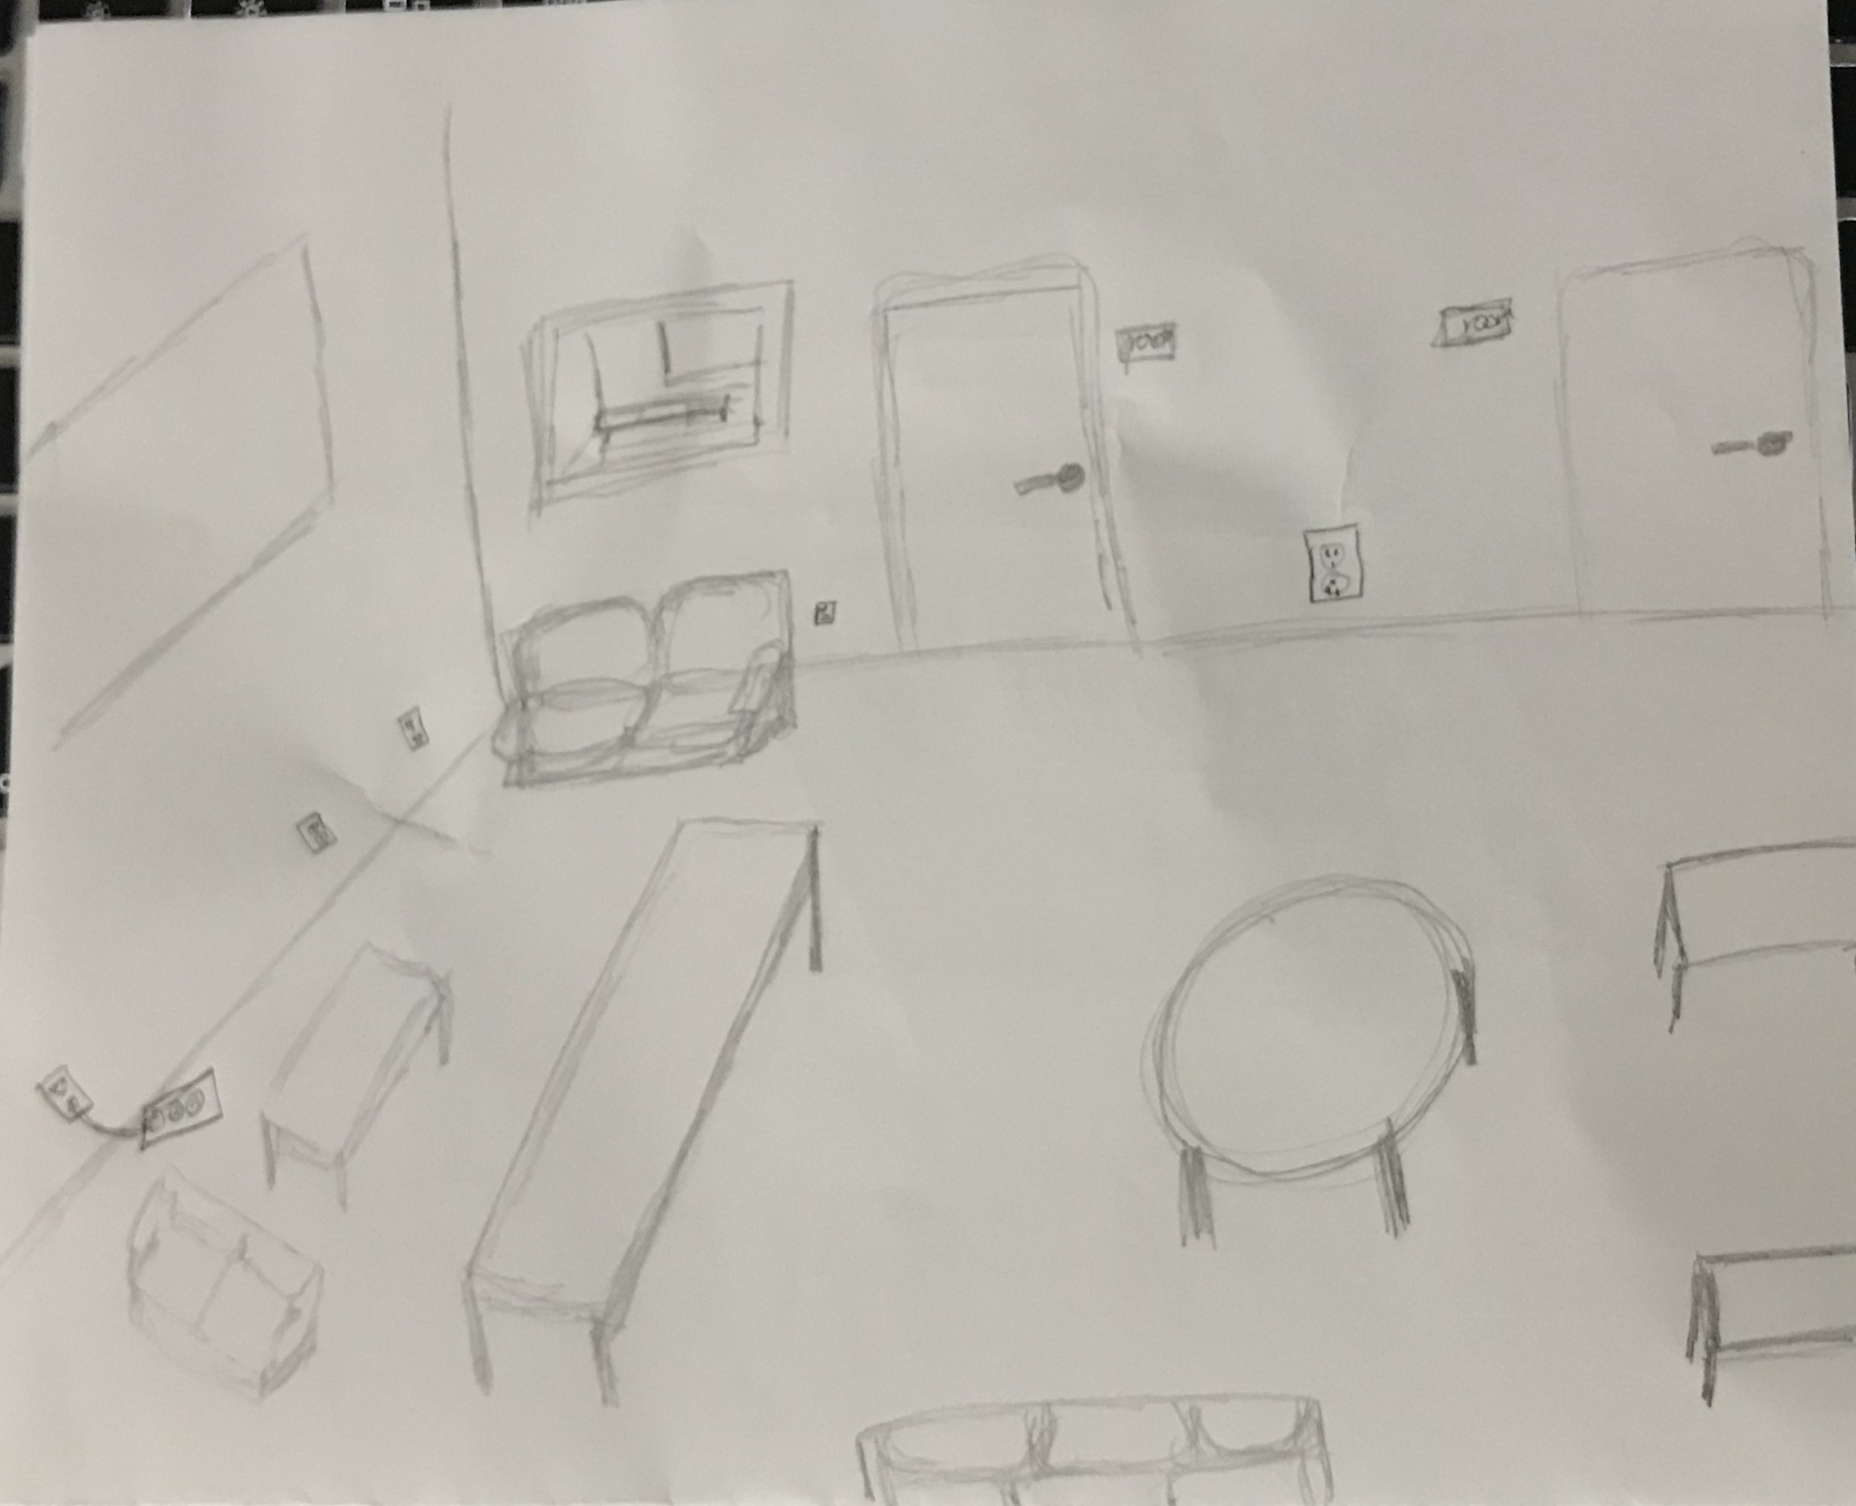

(SORRY I DON’T KNOW HOW TO DRAW NICE CHAIRS)

During the time I spent in CSEL, I noticed that students do not let go of their laptops and they treat them as if they were their cellphones most of the times. Most of the students were really focus on doing what they needed to do on their computer and pay all the attention to it, whether that was watching a lecture, coding, taking a quiz or assignment on moodle or canvas, or watching YouTube videos to learn more about the concept they were studying. There were some students that had their computer connected to their cellphone, therefore, they completely forgot about their cellphones and were texting and doing homework at the same time, in their laptops. The students that didn’t have their phone connected to their computer, would look at their phone once in a while but without letting the laptop be lonely for too long since it would go to sleep and it seems like they did not like the computer going to sleep, I can assume that it is because is annoying to have to type the password every time your laptop goes to sleep.

I also noticed how students would not leave their laptops by themselves. They would take it with them if they needed to go ask someone about a question or ask for help. Some students would even close their computers, grab them, go talk to other people in another table, come back to their table, and open the laptop again, and type the password to access the computer again. Some students would ask the person on their side to watch their laptop for them while they were gone asking somebody in the same room for help. I found interesting how no one wants to leave their computers, and if they do, they assign someone to watch after them, but this is only if they are in the same room. These last ones will make sure that the computer was locked before walking away.

In addition, when a student needed to go user the restroom or go get a coffee or water, they will look around carefully to see if they knew someone so they could watch their laptops after them, if there wasn’t someone they knew, some will sit back and not leave, and some will pack everything and take their backpack with them. It is really important to students to find someone trustworthy to watch their laptops while they are away from them. Also, students seem to not like sharing their devices, I can compare it to how we behave with our phones. There are even so many memes about how you pass your phone to show one picture and people start scrolling or looking at something else and you get annoyed. I find it exactly similar to the use of laptops. Students were not comfortable sharing them with other people.

I know the instructions say we should not be thinking of how to solve the problems, but then in the “Future Work” section, we are asked to write and/or sketch ideas of how to make a positive change that will impact what I observed. And well, this observation made me realize the value of being able to unlock your computer easily. I recently discover with the Apple update, that your laptop can be unlock with your Apple Watch when your apple watch is extremely close to your laptop. This feature solves the problem of having to unlock your computer every time it goes to sleep. However, not everybody has a Mac and an Apple Watch at the same time, therefore, the general solution I would suggest for the annoying password problem, is to make a touchpad in the laptops that is like the home button of the cellphones. This way you can unlock your computer by simple touching the touchpad with one of the fingers you previously programed in your settings. Letting your computer going to sleep while you’re texting or talking to somebody would not be a bother anymore. An alternative, if people do not want it in the touchpad, there could be a separate key in the keyboard that could read your fingerprint and have the same functionality I just described.

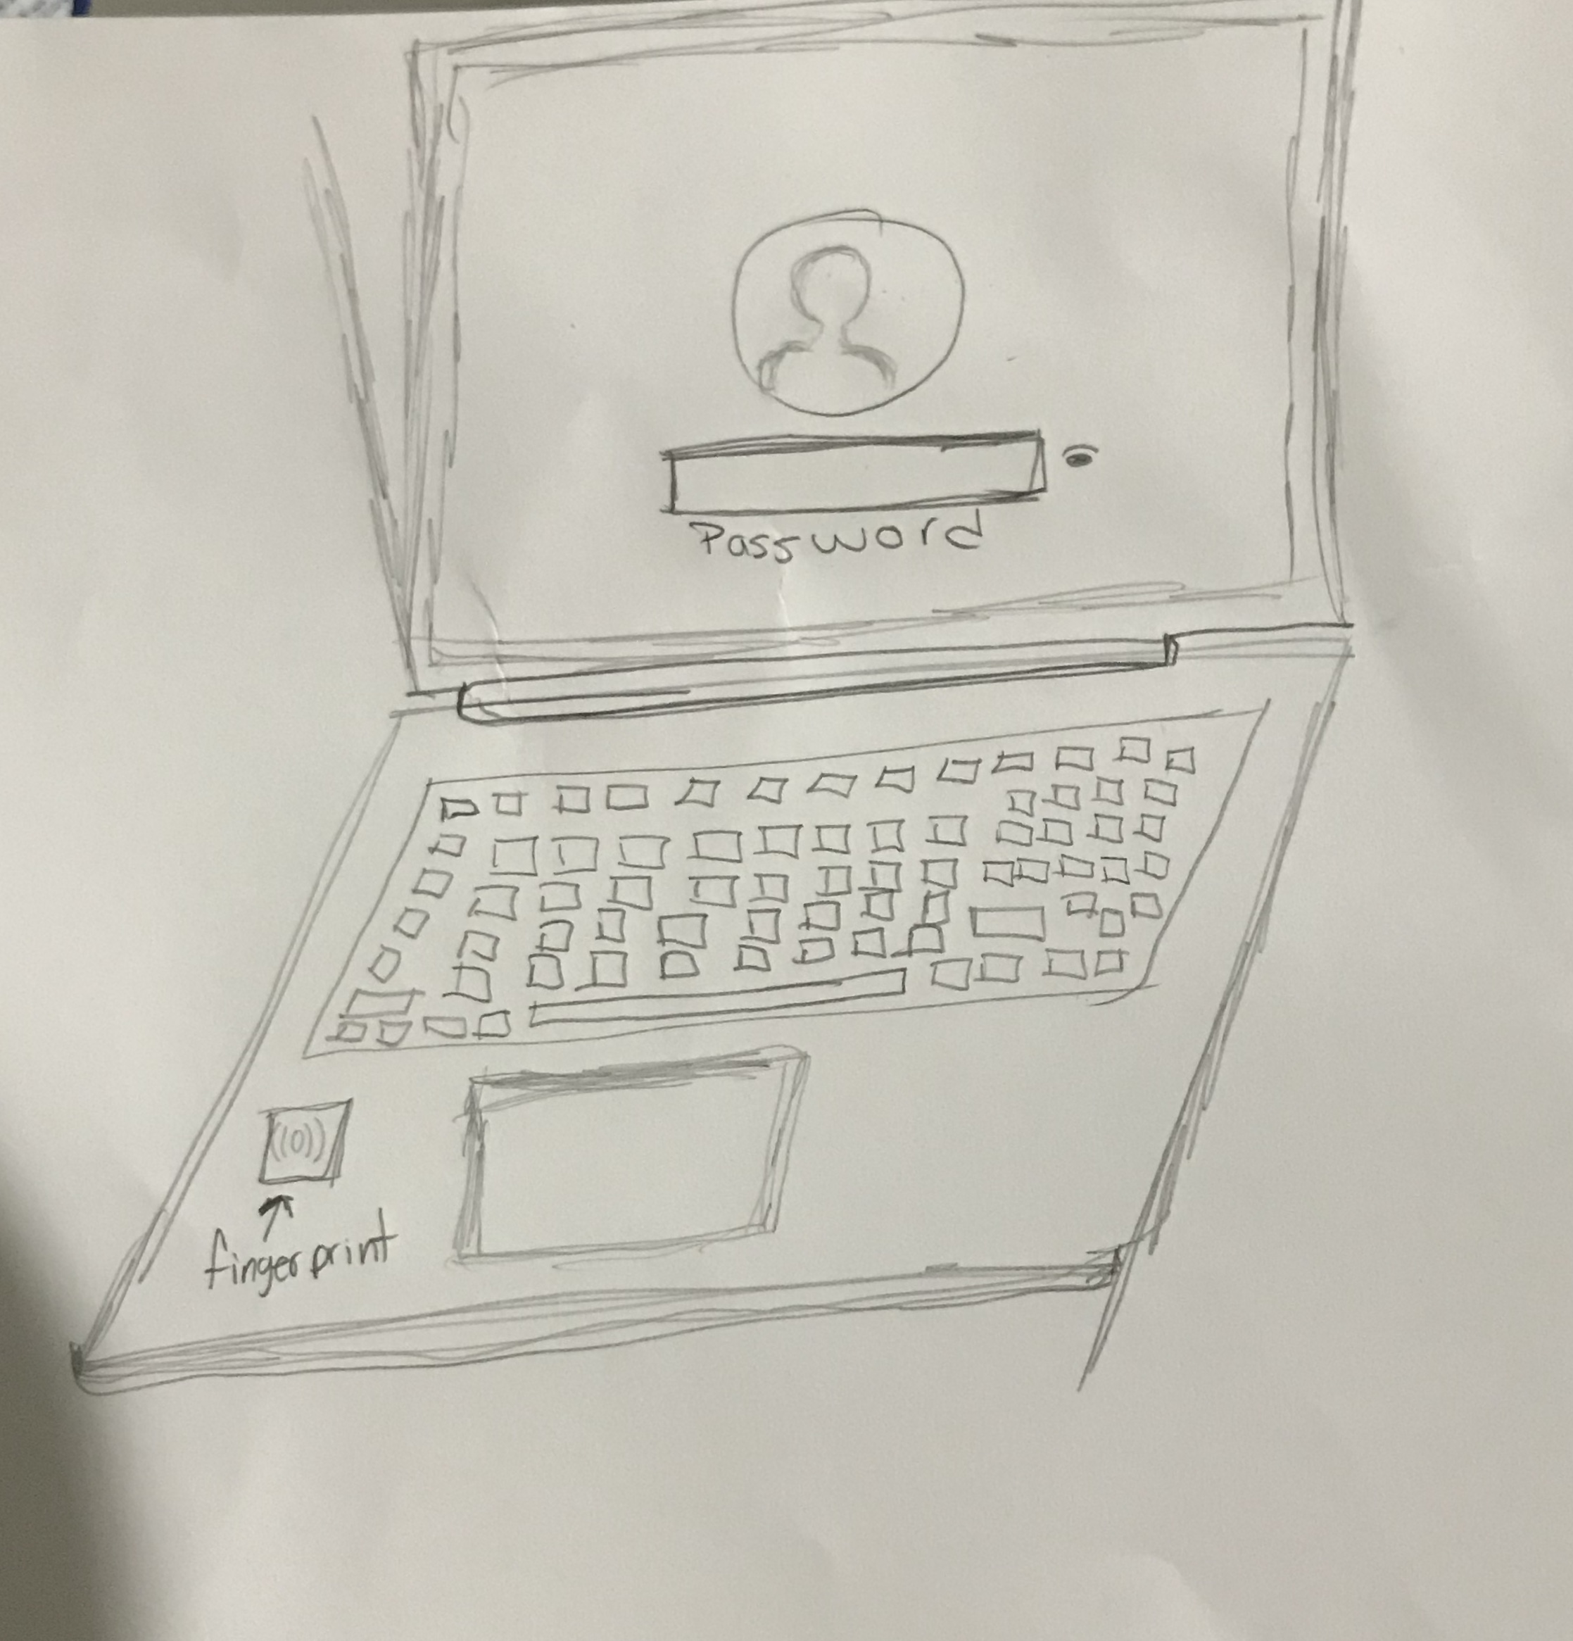

The other challenge, leaving your computer alone, is not something that could be fixed easily. Being able to always have your laptop at a reasonable distance to take care of it, is another concern of students but carrying a computer everywhere is not ideal when the computer is heavy. Many students, including me, carry around heavy computers because the 15” with large memory and processor are always heavy. I cannot think of a solution right now since people have been working on making lighter laptops but because of what having a good 15” laptop implies, it is not easy to make them lighter.

In conclusion, my observation took a direction that was probably biased since I discovered the Apple Watch feature to unlock my computer, about a day before planning on doing the observation. However, I think it was useful because this can open other ideas to the management of accessibility to the laptops. Laptops is a very valuable technology device for students and very useful, even thought we might not be able to do much with the weight of them, we can make them more user friendly. I fortunately did not run into any problem while I did the observation since it is pretty noticeable when people are trying to keep their computer without going to sleep, and when people are looking for someone around to take care of their devices, or just looking around to see if it’s a safe place to leave their laptops unattended. For the future, I would walk into a room with something already written in my paper so I can focus in something that I never thought it would exist, or something completely different that doesn’t involve something I just experienced.